Create Virtual Machine – ARM Template Lab

In this lab, you will learn how to create virtual machines using Visual Studio with ARM Template.

Creating a Virtual Machine using Visual Studio with ARM Template

In this task you will create a Virtual Machine in Visual Studio.

1. The solution is provided in the demos folder <URL>.
2. Extract the Solution named as VMDemo1.zip which contains a Visual Studio solution to create a VM using Visual Studio.
3. Open the solution file by double clicking on VMDemo1.sln and solution will be opened with the respective files.

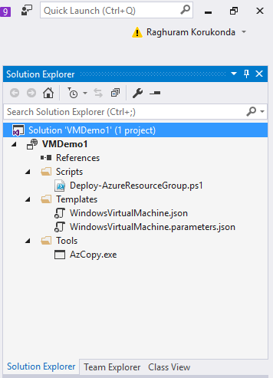

1. To deploy this application **Right click** and navigate to **Deploy** and **New Deployment** which will create a VM in your Azure Subscription with the respective resources which are needed for Virtual Machine like: a Virtual Machine, Storage to store the VHD, Virtual Network, with Subnets and Public IP, etc.

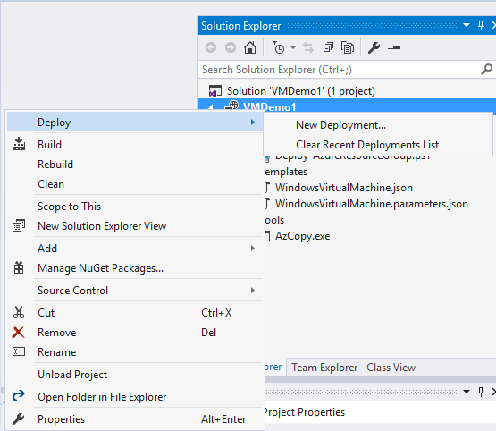

1. Login with your azure credentials and select the subscription Name if you have multiple subscriptions.
   * Select Subscription Name
   * Click on Resource Group – if you have already created a resource group it will be populated in the list or else you can click on <New> which will give you a pop-up for creating a Resource Group in a specific location.

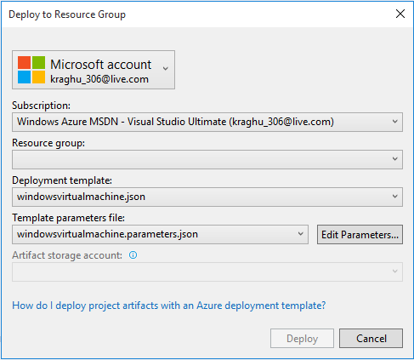

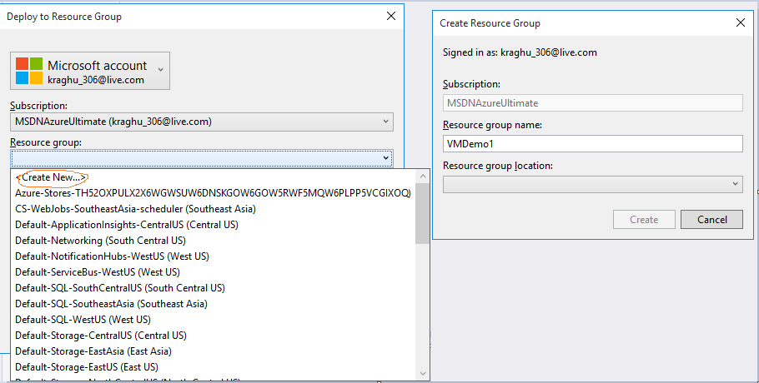

1. Click on Create which will create a specific resource group in your azure account and click on Edit Parameters which will populate with respective required credentials like username and password for VM and etc.

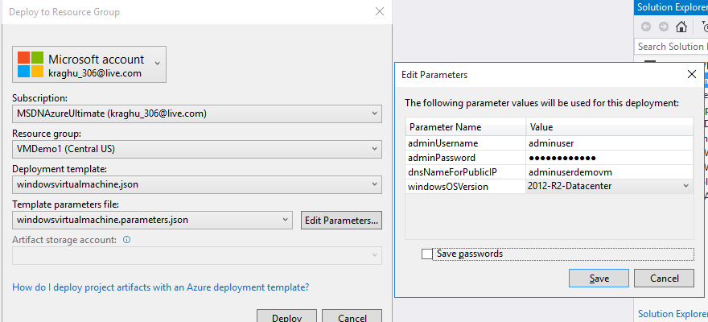

1. Click on **Save** and create **Deploy.**

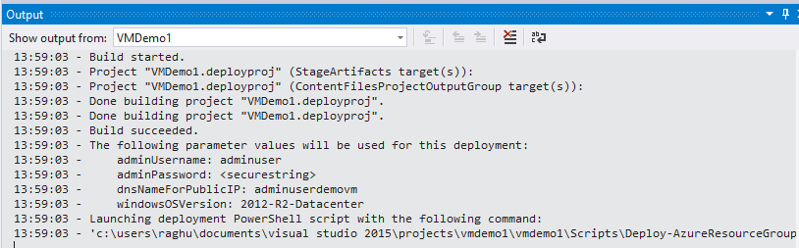

1. The Output file is also kept in the zip file named as **output.txt.**
2. You can check the status in the output section, once the resources are created we can now open Azure Portal and search for the Resource Group in the search box in Azure.
3. Open the respective resource group, we can see the below status

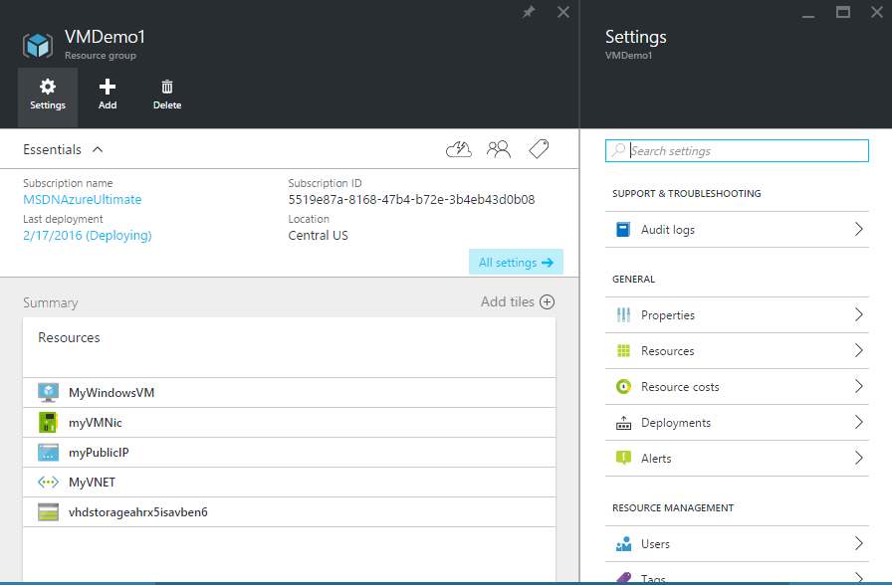

1. Click on the Virtual Machine created and click on Connect which will download RDP. Provide the username and password and connect to the machine.
2. If you can see in the resource group the list of resources that are created are:

* Virtual Machine: MyWindowsVM
* NIC: myVMNic
* Public IP: myPublicIP
* Virtual Network: MyVNET
* Storage: vhdstorageahrx5isavben6

1. **Delete Resources:** To delete the whole environment we can navigate to the respective Resource Group and click on Delete which will delete all the Resources inside it.

*END OF DOCUMENT*